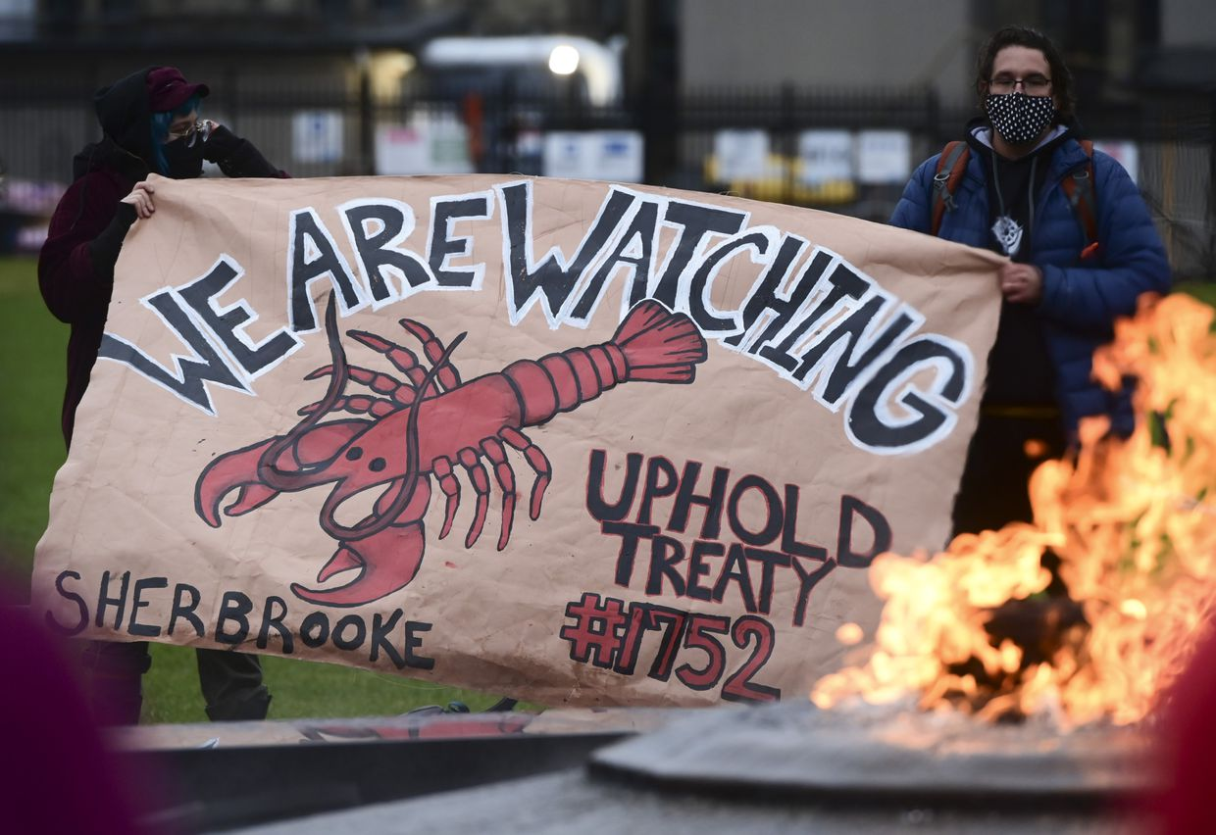
Background on the issue and historical context
On September 17th, 2020, members of the Sipekne'katik First Nation (part of the Mi ‘kmaw first nation group) launched their own indigenous lobster fishery before the official season opening on November 30th, 2020 (Slaughter,2020).
This early fishing effort led to conflict from other non-indigenous fishermen (men and women) disputing the Sipekne'katik lobster fishery on conservation grounds (Slaughter,2020).
Historical Events
(Kilpatrick,2020).
First nation groups believe they have unrestricted access to fish and sell their catch due to the Halifax treaties of 1760-1761. In these treaties, it was agreed that the thirty-five first nation bands would end hostilities against the British for the return of their fishing and hunting rights (Government of Canada, 2010a).
These rights were also backed up by the 1999 Marshall decision in the supreme court. That stated that first nation groups under the previous Halifax treaties could catch and sell their fish for a moderate livelihood (Government of Canada, 2010b). However, on November 17th, 1999, the supreme court further clarified its first ruling: it stated that the treaty rights could be regulated, if they were for key conservation or other critical public objectives (Government of Canada, 2010b).
Current Key events:
- October 13th A 200-person protest at a lobster pound in Middle West Pubnico resulted in vandalism and lobsters being taken out of the facility. That same day, a protest at a lobster pound in New Edinburgh resulted in the arson of a vehicle (Tutton, 2020).
- October 14th a lobster pound was burned to the ground Middle West Pubnico and remaining live lobster were poisoned (Young,2020).
- Throughout October, November, and December 2020, arrests were made and charges against several parties involved in the riots.
- In March 2021, Minister Bernadette Jordan issued a statement saying that fisheries protection and conservation officers would be ensuring that the lobster fishery is in accordance with DFO guidelines, i.e. no indigenous fishers would be allowed out of season. Minister Jordan also said that these measures would be in place while negotiations with the thirty-five first nations bands took place to discuss what a moderate livelihood fishery looks like in the future (Doucette,2021).
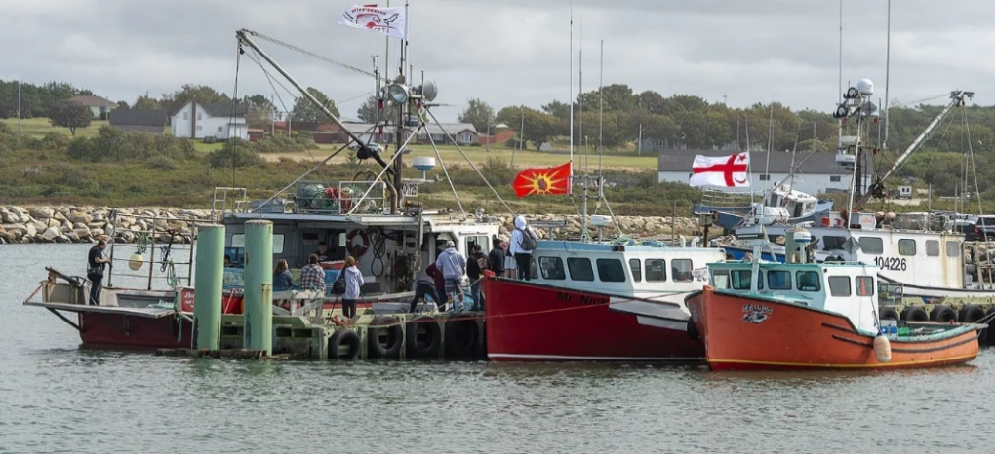
What policy options are there to bring peace?
So, after Minister Jordan’s statement in March, there are a few different options. As a policymaker, I would advise you to think about all available options before going back to minister Jordan and suggesting which option you might favor, before next season conducted in November 2021.
(Vaughan, 2020).
- Scientists, including Dr. Megan Bailey from Dalhousie University, suggested that the first nation lobster fishery effort would not damage the lobster populations (Smith, 2020). Therefore, we could allow the thirty-five first nation bands to fish without restriction, this again might anger non indigenous fishers.
- Another option is to maintain the current march policy and stop lobster fisheries for those fishing out of the official DFO Season. This would anger first nation groups and allies (Doucette,2021).
- The final option could be to allow first nations priority fishing for one or two weeks before the official season opening and ensure the stock status of the lobster before and during the fishery opens and closes. This option would allow first nations to prioritize a moderate livelihood without opening up the season super early, and this approach might appease both sides more.
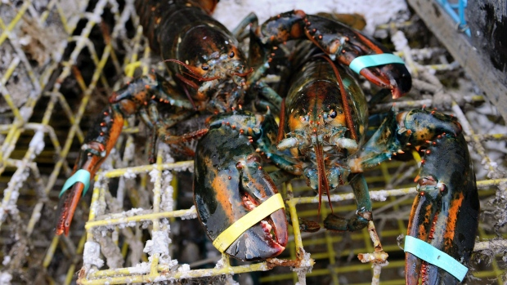
Overall, I believe these policy options can be edited, reviewed, and discussed with the thrifty five-first nations band’s this summer before next year’s lobster season. A peaceful co-existence can hopefully be negotiated and developed.

(The Canadian Press, 2020).
References
The Canadian press. (2020). N.S. Mi'kmaq want more than words from Ottawa in ongoing lobster conflict. Accessed on the 21st of May 2021 from https://www.bnnbloomberg.ca/n-s-mi-kmaq-want-more-than-words-from-ottawa-in-ongoing-lobster-conflict-1.1497877.
Doucette, K,. (2021). Ottawa wants Indigenous livelihood fisheries in N.S. part of commercial season. Canadian Press. Accessed on the 21st of May 2021 from https://atlantic.ctvnews.ca/ottawa-wants-indigenous-livelihood-fisheries-in-n-s-part-of-commercial-season-1.5332112.
Government of Canada,.2010a). Fact sheet on Peace and Friendship Treaties in the Maritimes and Gaspé. Accessed on the 21st of May 2021 from https://www.rcaanc-cirnac.gc.ca/eng/1100100028599/1539609517566.
Government of Canada,. (2010b). R. v. Marshall. Accessed on the 21st of May 2021 from https://www.rcaanc-cirnac.gc.ca/eng/1100100028614/1539611557572.
Kilpatrick, S,. (2020). Ottawa, Oct. 26: Supporters of the Mi'kmaq lobster fisheries gather on Parliament Hill. Accessed on the 21st of May 2021 from https://www.theglobeandmail.com/canada/article-mikmaq-fisheries-nova-scotia-treaty-rights-explainer/.
Slaughter,G., (2020). Mi'kmaq lobster dispute: A conflict brewing since the 1700s. CTV News. Accessed on the 21st of May 2021 from https://www.ctvnews.ca/canada/mi-kmaq-lobster-dispute-a-conflict-brewing-since-the-1700s-1.5153568.
Smith, E,. (2020). Scale of Sipekne'katik fishery won't harm lobster stocks, says prof. CBC News. Accessed on the 21st of May 2021 from https://www.cbc.ca/news/canada/nova-scotia/mi-kmaw-fishery-moderate-livelihood-megan-bailey-conservation-dalhousie-university-1.5734030.
Tutton,M,. (2020). Lobster catch destroyed, vehicle burned as tension rises over Indigenous fishery in N.S. Canadian Press. Accessed on the 21st of May 2021 from https://atlantic.ctvnews.ca/lobster-catch-destroyed-vehicle-burned-as-tension-rises-over-indigenous-fishery-in-n-s-1.5144540?cache=yes/
Vaughan, A,. (2020). Nova Scotia lobster dispute: Mi’kmaw fishery isn’t a threat to conservation, say scientists. Accessed on the 21st of May 2021 from https://theconversation.com/nova-scotia-lobster-dispute-mikmaw-fishery-isnt-a-threat-to-conservation-say-scientists-148396.
Young, B., (2020). Police presence grows in Saulnierville, N.S., after lobster pound destroyed by fire. CTV News. Accessed on the 21st of May 2021 from https://atlantic.ctvnews.ca/police-presence-grows-in-saulnierville-n-s-after-lobster-pound-destroyed-by-fire-1.5150307.

